Views from the Pews
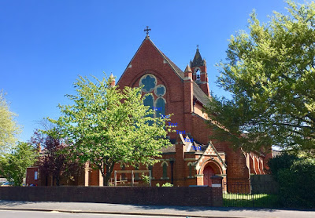
Photograph by D Jennings

It has been a very eventful six months in the history of St Mark’s Church here in Farnborough. There have been many highs. There have been a few lows.
First the highs – WE CAN SING AGAIN. Hallelujah, what joy this has brought to our Sunday Morning Worship. Church Breakfasts are back – a wonderful way for us to share food and fellowship together. They are a fantastic opportunity to get to know one another better – especially for those like ourselves that are new to the Church. Lent groups (with lunch – food is definitely a theme at St Mark’s) were a good opportunity to share our faith with each other at an informal, but still spiritual level. This is a Church built on strong historic foundations bur that still has a vital part to play in bringing God’s word to our local community. Take Easter for example; we are new to this style of worship, but found Palm Sunday (with the service starting in the Hall) and Easter (the meditations on Maundy Thursday and Good Friday and the celebrations - including food, on Easter Sunday) a great and inspiring way to mark this important Christian festival. Then there was the Platinum Jubilee. Great fun had by all – many thanks to the Social Committee and their helpers. The village atmosphere was superb and drew in a number of passers-by. And the food – what a feast. The visit of the Archdeacon the following day was well timed and provided us with some hope for the future of our Church.
Which brings me to the lows. It is very unfortunate that the attempt at a Church graft has failed. Disappointing for everyone – the Church, the priest concerned and the Diocese. We anxiously await and pray for, proposals for the way forward. In the meantime, we are incredibly grateful to Haydon and the other visiting priests who are able to serve the Eucharist for us. There is also now a team within the Church willing and able to lead and support non-eucharist based services for when a priest is not available. They provide service leadership, readings, prayers and biblical based studies / addresses. I am sure more volunteers would be most appreciated.
As newcomers, we especially appreciate the welcome we have received from you all – even when everyone had to wear masks etc. We look forward to many years of learning and worship together (and perhaps food?). Whatever the future holds St Mark’s will stay true to its core values of traditional high church worship, a warm welcome to all who want to attend and of course FOOD (spiritual and physical).

Chris Wright
22/6/2022

