St Mark’s, Farnborough
Spring Services 2021

Date | Services
14 March | Sarah Norbron  Talk – Stephen Linton
21 March | Martin James
28 March  Palm Sunday | Richard Cobbold  Talk – John Edwards
4 April  Easter Sunday | Martin James

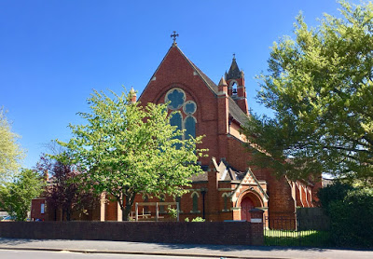
Photograph by D Jennings

